NATIONAL CUP ENDS IN PENALTIES

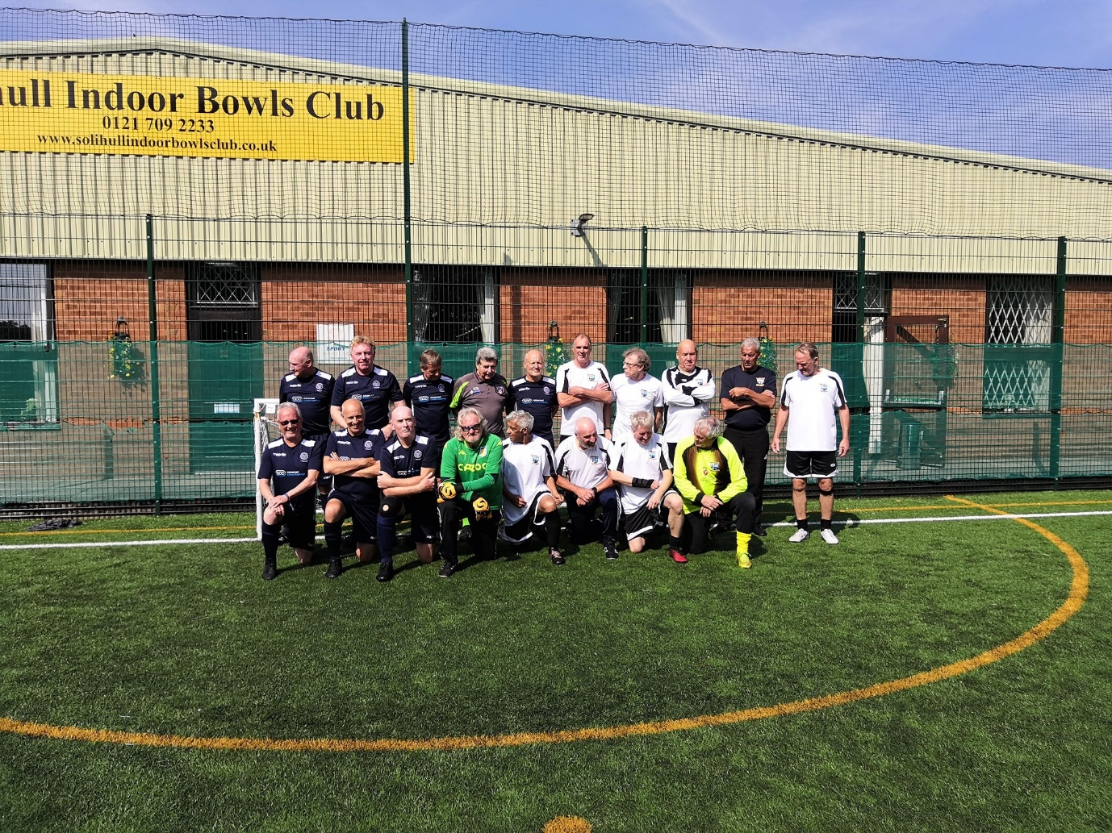

A National Cup 3rd round tie saw the usual tight, low scoring encounter between these sides took place at the Solihull Walking Football Centre on Sunday 5th Sept.
A typically competitive start saw lots of stoppages for both running and minimal contact, though there was no malice in any of the contact calls, and the referee had to call both teams together midway through the half to remind them of what he required of them in order to complete the game with enough players for a legitimate result.
Several players were already on 2 warnings, but the game settled down from that point and both teams showed true quality in some of their football and each keeper had to be at their best on several occasions to keep the score level. Defences were mostly on top, and play was concentrated in midfield for long periods of time as both Birmingham and Hartshill probed for an opportunity to get break clear, MARTIN BARBER and ROGER PURCHASE kept things well in hand at the back for Birmingham, ably assisted by their midfielders.
The second half carried on with plenty of effort, skill and resolute defending from both sides and extra time followed in the same vein.
FINAL SCORE 0-0 after extra time.
As it was a cup game we then had to go to penalties. 3 penalties per side initially and that was sufficient to see Hartshill go through to round 4. MARK EVANS buried his penalty into the top corner and LES DAWSON saved the 2nd Hartshill penalty but, unfortunately for Birmingham their other 2 penalty takers failed to score whilst the 3rd Hartshill penalty hit the back of the net.
HARTSHILL STROLLERS win 1-0 after penalties.

