ENGLAND INTER GENDER MATCHES
Last weekend saw three England inter gender team matches played at St Georges Park. The teams were Men’s over 75’s, Men’s over 65’s and Women’s over 60’s. Birmingham had two players in the 75’s (Geoff Harman and Derek Adderley) with Billy Pears as their first team coach, and Jan Trigg in the women’s over 60’s.
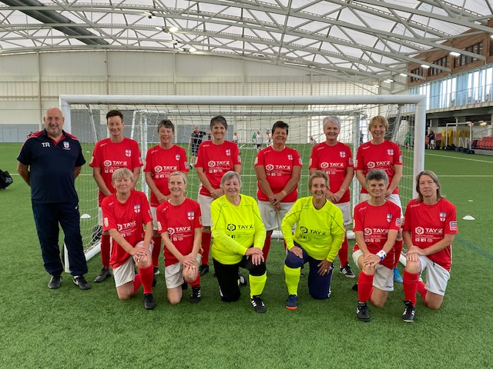
The men’s 65’s won all their games, the women won two lost two and unfortunately the 75’s lost all four. A fantastic experience for all those who got the opportunity to play.

