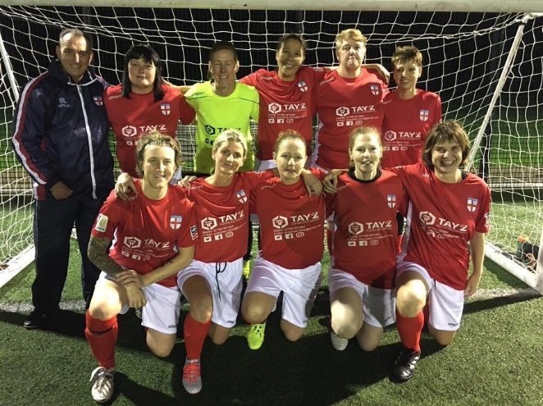
Walking all over the World
England Over 60s Walking Football Manager has had a very busy few months.
In October he took on the additional responsibility of organizing trials for the first England Women’s Walking Football teams at Over 40 and 50. Having run 2 trials and selected two squads, he selected a mixed team to travel to Guernsey to play the first ever Women’s Walking Football International – with England winning 2-0

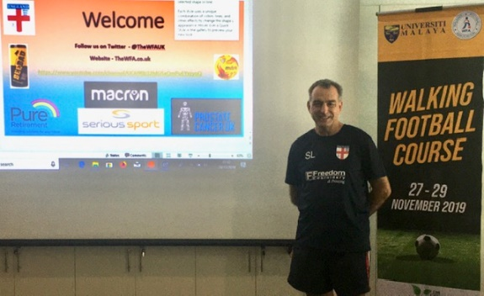
In November, with 2 colleagues he travelled to Malaysia and Singapore to train referees and run a coaches training course – that he wrote with his son Ross, a UEFA B Licensed Coach. With over 30 completing the referees course and 20 the coaches course.

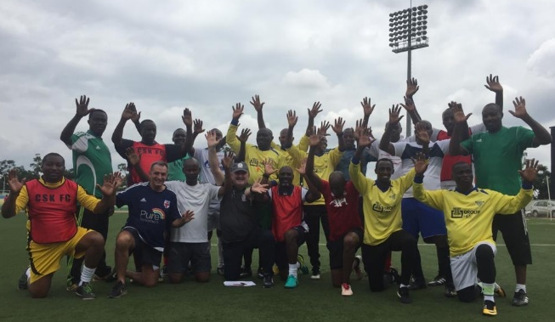
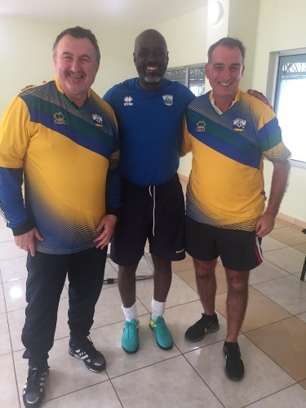
In January, he was off to Rwanda where more training courses for coaches and referees took place with over 20 completing each. He also took old Abbeymead Rovers kit over, which was received gratefully and worn immediately.

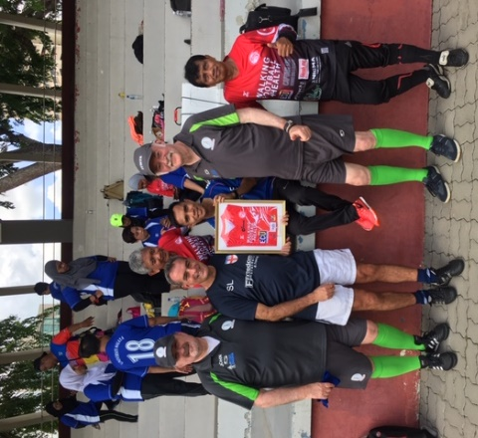
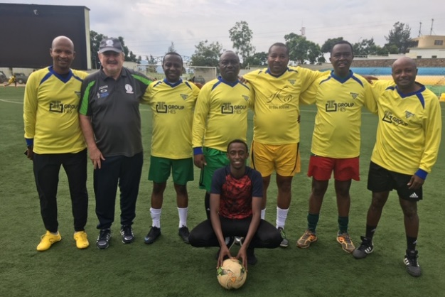

Finally, as part of a short break with wife Judith, he contacted a Walking Football group on The Algarve in Portugal and met up and joined in with one of their regular sessions
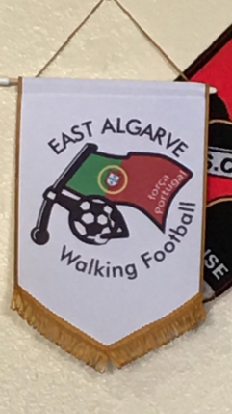
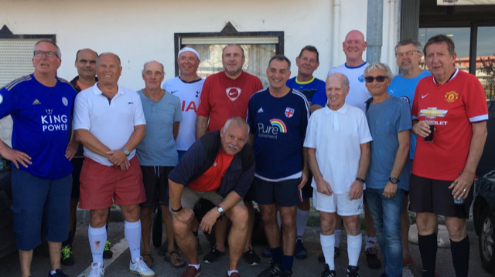

All this comes ahead of busy few months in the build up to the first ever WFA World Nations Cup in Manchester, being held at the Etihad complex at the end of May. A training session is planned each month in the build-up – Sheffield in February, Der by in March, St Georges Park in April with one final session still to be planned. Having won the Euros last year, along with the England 50s, Langworthy and his colleague Paul Murtagh, who manages the 50s hope to be the first England managers at senior, or very senior level to win a world cup

